# 



**School of InfoComm Technology**

**Data Discovery & Visualisation**

Diploma in Data Science

Diploma in Information Technology

October 2023 Semester

**ASSIGNMENT 1**

**(Individual Assignment)**

**Submission Deadline:**

**Tentatively 8th December 2023 (Wednesday), 2359 hrs**

|  |  |  |
| --- | --- | --- |
| **Student Name** | **:** | Tan Jun Yu Zavier |
| **Student Number** | **:** | S10255651 |

**Penalty for late submission:**

10% of the marks will be deducted every calendar day after the deadline.

**NO** submission will be accepted after 14th December 2023 (Tuesday), 2359 hrs

**Table of Contents**

Introduction 4

Background 4

Problem Statement 4

1. Explanatory Questions 5

1.1 Why these Stakeholders should care 5

1.1.1 Policymakers and Government Officials: 6

1.1.2 Healthcare Professionals: 6

1.1.3 General Public: 6

1.2 Who’s my Targeted Audience? 7

2) Data Preparation 8

2.1 Describe the data state (e.g., is it clean, is it complete). Do you expect to do substantial data cleanup? 8

2.2 How will you prepare the data to be suitable for exploration and analysis? Describe the steps involved in detail. 10

2.2.1 Creating a Data Dictionary 10

2.2.2 Using Calculated fields 11

2.3 Further Research 12

2.3.1 BMI Research 12

2.3.2 Alcohol Consumption Research 13

2.3.3 GDP per capita Research 13

2.3.4 Immunization Coverage Research 14

2.3.5 HIV Research 14

3) Exploratory Data Analysis and Visualisation 15

3.1 Data Model 15

3.2 Life Expectancy 16

3.2.1 What is the annual average life expectancy trend in Thailand and how does it compare to the other ASEAN countries? What are the average life expectancy observed across ASEAN countries over the years? 16

3.3 Alcohol Consumption 18

3.3.1 What is the trend of alcohol consumption per year in Thailand, and how does the level of alcohol consumption in Thailand compare with other ASEAN countries? 18

3.4 BMI 20

3.4.1 What is the trend of BMI per year in Thailand, and how does the BMI compare with other ASEAN countries? 20

3.5 Incidence of HIV 22

3.5.1 What is the incidence of HIV in Thailand, and how does it compare with the prevalence of HIV in other ASEAN countries? 22

3.6 GDP per capita 24

3.6.1 What are the trends in GDP per Capita? 24

3.6.2 How does GDP per capita compare with the average Life Expectancy? 25

3.7 Immunization Coverage 27

3.7.1 How does Immunization Coverage look like in Thailand and what is the trend in immunization coverage per year across ASEAN countries. 27

3.8 Mortality Rate 29

3.8.1 What are the mortality rates in Thailand, and how they evolved over the years? Where does Thailand’s mortality rate stand in comparison to other ASEAN countries? 29

4) Dashboard 31

4.1 Life Expectancy Dashboard 32

4.2 Alcohol Consumption Dashboard 33

4.3 BMI Dashboard 34

4.4 HIV Dashboard 35

4.5 Immunization Coverage Dashboard 36

4.6 Mortality Dashboard 37

5) Recommendation Summary 38

5.1 Raise more awareness by educating the public 38

5.2 Advocate for better healthcare policies 38

5.3 Ensure kids take mandatory immunization coverage 38

6) Conclusion 39

6.1 Reflection 39

6.1.1 How have your findings on ASEAN countries challenged or broadened your understanding of regional diversity and interconnectivity? 39

6.1.2 What are some key challenges and opportunities you observed among the ASEAN countries in terms of their socio-economic development? How do these findings contribute to your understanding of the ASEAN community? 39

6.1.3 In what ways do the findings on ASEAN countries inspire you to reflect on Singapore’s position within the region and its role in fostering regional collaboration and growth? 39

6.2 Conclusion 40

7) Reference 41

# Introduction

### Background

My dataset (*Life-Expectancy-Data.xlsx) is related to Goal 3 which ensures healthy lives and promotes well-being for all at all ages. My focus will be on the Life expectancy in Thailand and where it stands among other ASEAN countries.

As I did my research, I found out that life expectancy is a very important as many factors can affect it. So, my focus would be to find out more about factors affect life expectancy. As I want to convey the significance of how these factors can impact life expectancy, which could lead to either a longer or shorter life expectancy, having a longer life expectancy means generally lead to having a great quality of life or at least healthy enough especially when transitioning to their later stages in life.

### Problem Statement

How can we ensure that quality and affordable healthcare are accessible to the residents of Thailand and are being educated on the risk of the factors that can significantly impact life expectancy?

# Explanatory Questions

In this section I will be showing questions that help gain meaningful insights on health challenges that affect life expectancy. These questions will introduce life expectancy in a glance, followed by the other factors that have impacted life expectancy one way or another.

**Life Expectancy**

* What is the annual average life expectancy trend in Thailand and how does it compare to the other ASEAN countries? What is the average life expectancy observed across ASEAN countries over the years?

**Alcohol Consumption**

* What is the trend of alcohol consumption per year in Thailand, and how does the level of alcohol consumption in Thailand compare with other ASEAN countries?

**BMI**

* What is the trend of BMI per year in Thailand, and how does the BMI compare with other ASEAN countries?

**Incidence of HIV**

* What is the incidence of HIV in Thailand, and how does it compare with the prevalence of HIV in other ASEAN countries?

**GDP per capita**

* What are the trends in GDP per Capita?
* How does GDP per capita compare with the average life expectancy trends?

**Immunization Coverage**

* How does Immunization Coverage look like in Thailand and what is the trend in Immunization Coverage per year across ASEAN countries?

**Mortality Rates**

* What are the mortality rates in Thailand, and how they evolved over the years? Where does Thailand’s mortality rate stand in comparison to other ASEAN countries?

In the next section, I’ll list the various stakeholders that will benefit from these visuals and why they should care.

## Why these Stakeholders should care

Based on my explanatory questions, These factors are shared not only across ASEAN countries but the entire globe. It offers great insights to various stakeholders, and it also raises awareness on the things that can be further improved to achieve progress about Goal 3 of the Sustainable Development on Good Health & Wellness. With the ability to compare how ASEAN countries fair against the other countries. Below are reasons why they should care.

### 1.1.1 Policymakers and Government Officials:

* *Making informed decisions*

Policymakers and Government officials can view the trends in life expectancy, allowing them to leverage from these insights to come up with health policies that can address specific needs and challenges faced by their respective countries. Henceforth acting on it can lead to improved public health and better quality of life.

* *Necessary Interventions*

Policymakers and government officials can plan appropriately on how they should allocate their resources to aid members of the public, so that members of the public can have access to quality healthcare especially areas that need them the most as compared to others. Therefore, maximizing the impact of healthcare initiatives made by the officials.

### 1.1.2 Healthcare Professionals:

* *Optimized Resource Allocation*

Exploring the differences in health indicators can help facilitate optimized resource allocation. That way healthcare providers can strategically plan and distributes resources to departments that may have a greater need for it. This helps ensures that medicals services are readily available and accessible to address the diverse health profiles of developing and developed ASEAN countries.

* *Strategic Healthcare Planning*

Understanding the correlation between a country’s economic development (GDP) and healthcare practices and interventions allows for better strategic planning. Therefore, healthcare can better understand that if there is a positive correlation, it shows that the economy is improving which can also lead to improvement in the healthcare sector. While on the other hand, negative correlation could mean that if economy is in a decline, then the healthcare sector could be heavily impacted and eventually unable to provide quality healthcare to the public. Therefore, carefully consideration and strategic planning will be great in the face of adversity.

### 1.1.3 General Public:

* *Health Awareness*

By understanding the factors influencing life expectancy, it provides the public with valuable insights into the type of health issues that is affecting it. Which can raise awareness about these health issues and educate the public especially in schools on how to prevent and protect themselves.

* *Community Engagement*

After knowing the factors that are influencing life expectancy, communities can host health-related activities and initiatives to address common health issues. By actively participating in these kinds of activities, it improves the general public health and also foster a greater sense of collective responsibility of taking care of their well-being.

## Who’s my Targeted Audience?

**Ministry of Public Health of Thailand (MOPH)**

As my research revolves around mainly Thailand and other ASEAN countries, the target audience I believe that will benefit from my data visualizations are the Ministry of Public Health of Thailand (MOPH). MOPH are responsible for the oversight of the public health in Thailand. Therefore, with my visuals they will be able to understand where they stand on certain health issues, how they can improve and how they compare against other ASEAN countries. This allows them to raise awareness about these health issues through workshops or programs and advocate for resources to address these challenges in order to maintain a good positive impact of the public health.

# 2) Data Preparation

## Describe the data state (e.g., is it clean, is it complete). Do you expect to do substantial data cleanup?

With the dataset that I am using ‘Life-Expectancy-Data-Updated’ as a csv format. I converted it to a Xlsx format so that I can understand and read the data inside the file more easily.

Dataset File Structure: The file consists of 21 Columns (Variables) and 2865 rows (observations). According to the metadata provided on the website, the columns are listed below.

|  |  |  |
| --- | --- | --- |
| Column# | Column  Name | Description |
| 1 | Country | List of the 179 countries |
| 2 | Region | 179 countries are distributed in 9 regions. E.g., Africa, Asia, Oceania, European Union, Rest of Europe and etc. |
| 3 | Year | Years observed from 2000 to 2015 |
| 4 | Infant_deaths | Represents infant deaths per 1000 population |
| 5 | Under_five_deaths | Represents deaths of children under five years old per 1000 population |
| 6 | Adult Mortality | Represents deaths of adults per 1000 population |
| 7 | Alcohol_Consumption | Represents alcohol consumption that is recorded in liters of pure alcohol per capita with 15+ years old |
| 8 | Hepatitis_B | Represents % of coverage of Hepatitis B (HelpB3) immunization among 1-year-olds |
| 9 | Measles | Represents % of coverage of Measle containing vaccine first dose (MCV1) immunization among 1-year-olds |
| 10 | BMI | BMI is a measure of nutritional status in adults. It is defined as a person’s weight in kilograms divided by the square of that person’s height in meters (kg/m2) |
| 11 | Polio | Represents % of coverage of Polio (Pol3) immunization among 1-years-olds |
| 12 | Diphtheria | Represents % of coverage of Diphtheria tetanus toxoid and pertussis (DTP3) immunization among 1-years-olds |
| 13 | Incidents_HIV | Incidents of HIV per 1000 population aged 15-49 |
| 14 | GDP_per_capita | GDP per capita in current USD |
| 15 | Population_mln | Total population in millions |
| 16 | Thinness_ten_nineteen_years | Prevalence of thinness among adolescents aged 10-19 years. BMI <- 2 standard deviations below the median |
| 17 | Thinness_five_nine_years | Prevalance of thinness among children aged 5-9 years. BMI <- 2 standard deviations below the median |
| 18 | Schooling | Average years that people aged 25+ spent in formal education |
| 19 | Economy_status_Developed | Developed country |
| 20 | Economy_status_Developing | Developing country |
| 21 | Life_expectancy | Average life expectancy of both genders in different years from 2010 to 2015 |

**Tabel 2.1 – Metadata**

The dataset that I am using is clean and complete as it is the fixed and updated dataset of the original ‘Life-expectancy.csv’. Here are some issues with the original dataset.

Firstly, the original dataset had inaccurate data and a lot of values were missing. Secondly the data that had missing values, were filled by:

1. Filling data with the closet three-year average. If a specific country had a missing value in any years, the data was filled with the closest three-year average.
2. Filling data with the average of the Region. If a specific country was missing values for all year, the data was filled with the average of the Region (eg. Asia, Africa, European Union, etc.)

Data is adjusted and the missing values are filled. Countries that were missing more than 4 data columns were omitted from the database. Examples of these countries are Sudan, South Sudan, and North Korea.

The database has one variable that categorizes countries into two groups: **Developed vs Developing** countries. According to World Trade Organization, each country [defines](https://www.wto.org/english/tratop_e/devel_e/d1who_e.htm) itself as “Developed” or “Developing”. Therefore, it is challenging to categorize countries. UN has a [list](https://www.un.org/en/development/desa/policy/wesp/wesp_current/2014wesp_country_classification.pdf) dated 2014 that for analytical purposes classifies countries as developed, in transition, and developing economies. Countries that have economies in transition have similar characteristics to the countries that are categorized as developed or developing countries. Countries have been grouped according to their Gross National Income per capita. As a result, nations were divided into four income groups: high-income, higher-middle-income, lower-middle-income, and low-income. The levels of Gross Domestic Income are set by the World Bank to ensure comparability.

Therefore, no clean-up was required on my side as I found the updated and fixed dataset, so doing the visuals was easier and more accurate.

## How will you prepare the data to be suitable for exploration and analysis? Describe the steps involved in detail.

### Creating a Data Dictionary

In the dataset, no data dictionary was available. To better understand and prepare, I looked through the dataset and created a data dictionary. The data dictionary is a compilation of my understanding of the dataset and a reference when doing my visuals.

**Table 2.2 – Dataset at first glance**

**Table 2.3 – Data Dictionary**

The above data dictionary has been created with my understanding of the dataset. I created a description of what the dataset entails, followed by a few other details. Afterwards I created the data dictionary table and separated it into 3 parts, Variable, Type and Description. Through this data dictionary, it aims to provide a simpler understanding of the dataset and for easy reference.

### Using Calculated fields

I created 1 calculated field, ‘Country Filter’ which is to filter to either view ASEAN countries which consists of

* Singapore
* Malaysia
* Thailand
* Indonesia
* Philippines
* Vietnam
* Myanmar
* Cambodia
* Lao PDR
* Brunei Darussalam
* Timor Leste

For the other countries, it labeled and grouped all under other countries. Therefore, being able to view all countries or either ASEAN or others. Below is the calculation used to create the filter.

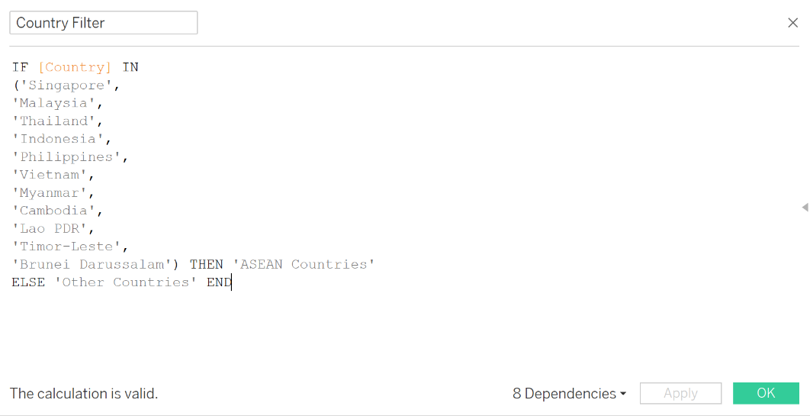

**Table 2.4 – Data Dictionary**

As shown in the above, I used an If & Else statement to create the calculated field. By doing so, it created the filter I needed to separate ASEAN countries from every country listed and put them as ‘other countries’.

## Further Research

In order to progress towards creating my visuals, it is important to know what I am actually researching on, about what it is and how it works. Below are some of the website I’ve gone through to educate myself on what are the definitions and what they represent to give myself a better understanding so that I can also understand the visuals that I will be creating later.

### BMI Research

**Table 2.5**

### Alcohol Consumption Research

**Table 2.6**

### GDP per capita Research

**Table 2.7**

### Immunization Coverage Research

**Table 2.8**

### HIV Research

**Table 2.9**

# 3) Exploratory Data Analysis and Visualisation

* Perform univariate and multivariate analysis on your dataset.
* Using descriptive analytics techniques (i.e. statistical analysis, correlation analysis, basic visualisations, etc.), document your findings.
* Identify the core findings and insights that help to answer the exploratory questions identified earlier. Create the visualisations accordingly.
* Describe each visualisation by highlighting the exploratory questions it answers.
* Where necessary, explain how to interpret the visualisations to answer the exploratory questions (e.g. interactive elements).

## 3.1 Data Model

This is how the data model looks like:

**Table 3.1 - Data Model**

With the data model, I will be using it to answer the following questions:

**Life Expectancy**

* What is the annual average life expectancy trend in Thailand and how does it compare to the other ASEAN countries? What is the average life expectancy observed across ASEAN countries over the years?

**Alcohol Consumption**

* What is the trend of alcohol consumption per year in Thailand, and how does the level of alcohol consumption in Thailand compare with other ASEAN countries?

**BMI**

* What is the trend of BMI per year in Thailand, and how does the BMI compare with other ASEAN countries?

**Incidence of HIV**

* What is the incidence of HIV in Thailand, and how does it compare with the prevalence of HIV in other ASEAN countries?

**GDP per capita**

* What are the trends in GDP per Capita?
* How does GDP per capita compare with the average life expectancy trends?

**Immunization Coverage**

* How does Immunization Coverage look like in Thailand and what is the trend in Immunization Coverage per year across ASEAN countries?

**Mortality Rates**

* What are the mortality rates in Thailand, and how they evolved over the years? Where does Thailand’s mortality rate stand in comparison to other ASEAN countries?

## 3.2 Life Expectancy

### 3.2.1 What is the annual average life expectancy trend in Thailand and how does it compare to the other ASEAN countries? What are the average life expectancy observed across ASEAN countries over the years?

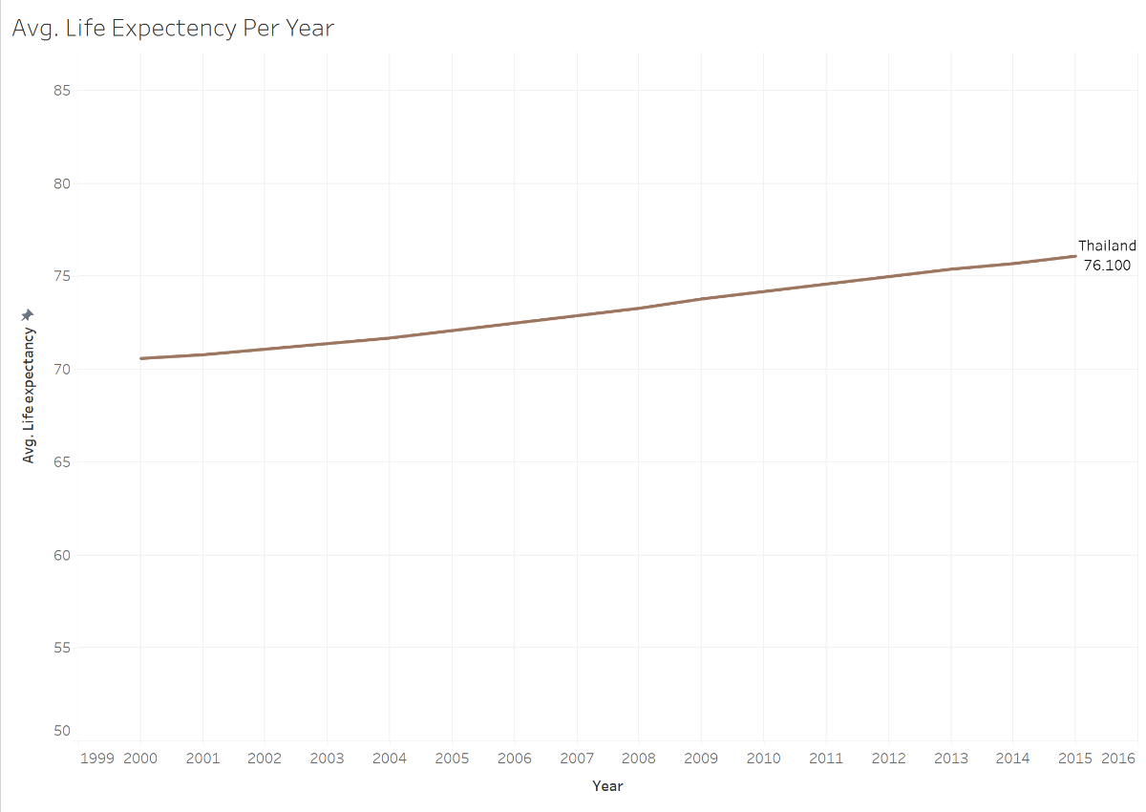

**Table 3.2**

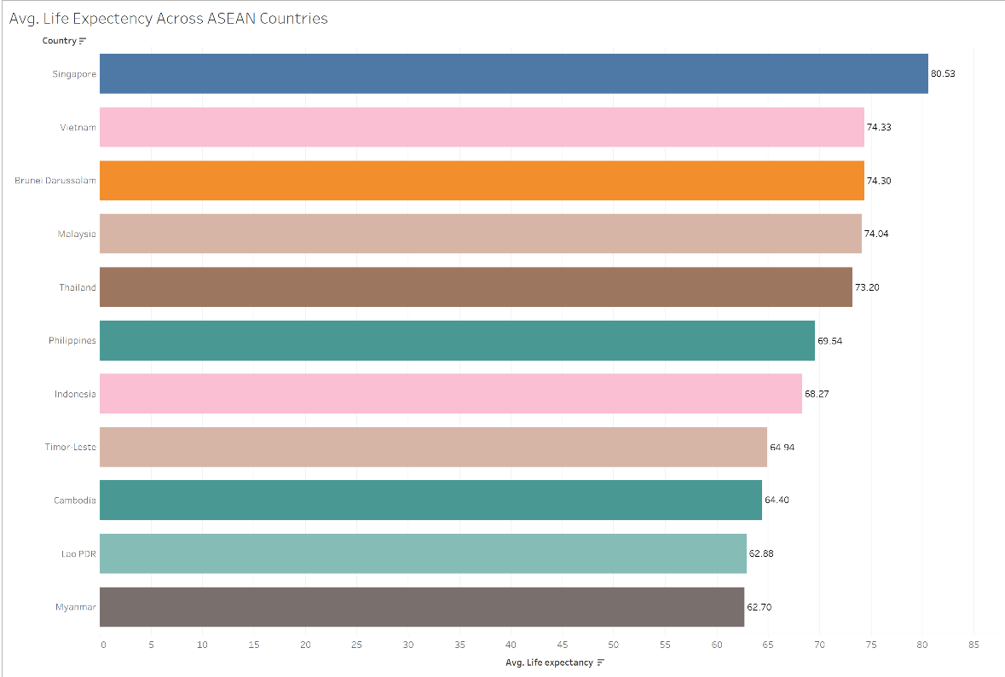

**Table 3.3**

**Table 3.4**

**Interpretation**

Based on the above visuals provided, it answers three parts of the question. It shows the average life expectancy in Thailand per year, how they compare to other ASEAN countries. It also highlights life expectancy across ASEAN countries over the years in the form of a tree map.

**Purpose**

With this map, firstly it is easier to compare the average life expectancy among the ASEAN countries, identifying those countries that have a higher or lower life expectancy. It is also provides insights into the health outcomes in Thailand and how it compares to other ASEAN countries. Secondly, we can see that those with higher life expectancy will have a likely higher chance of receiving quality healthcare while those with lower life expectancy might not which can be considered a factor in resulting a lower life expectancy. By showing these disparities, government officials can intervene to take action to improve the healthcare sector so that the average life expectancy can improve overtime. Lastly, it also raises public awareness and people will start taking care of themselves.

## 3.3 Alcohol Consumption

### 3.3.1 What is the trend of alcohol consumption per year in Thailand, and how does the level of alcohol consumption in Thailand compare with other ASEAN countries?

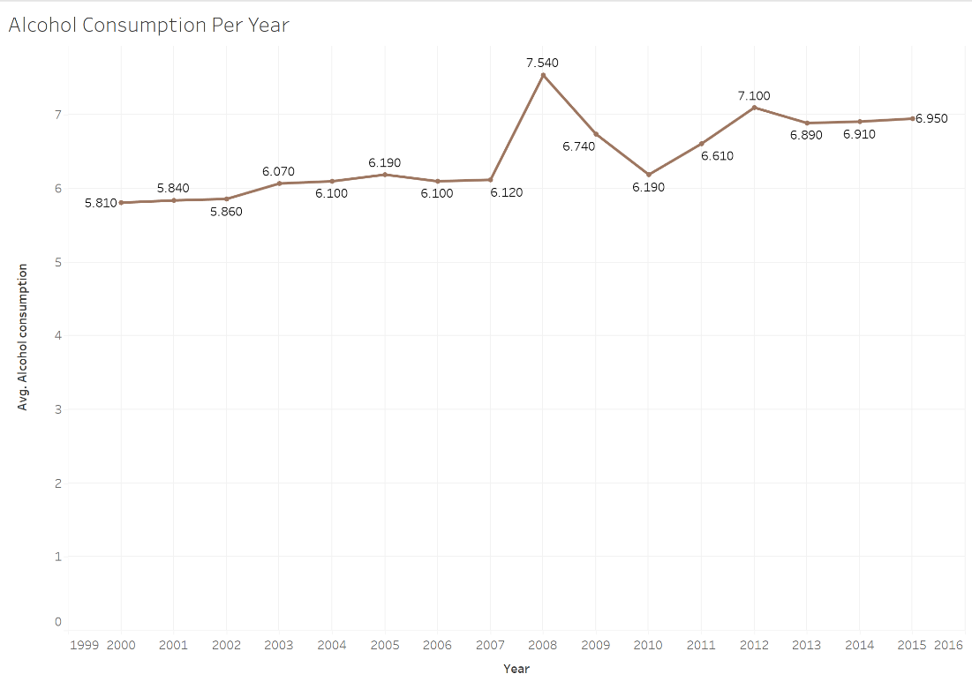

**Table 3.5**

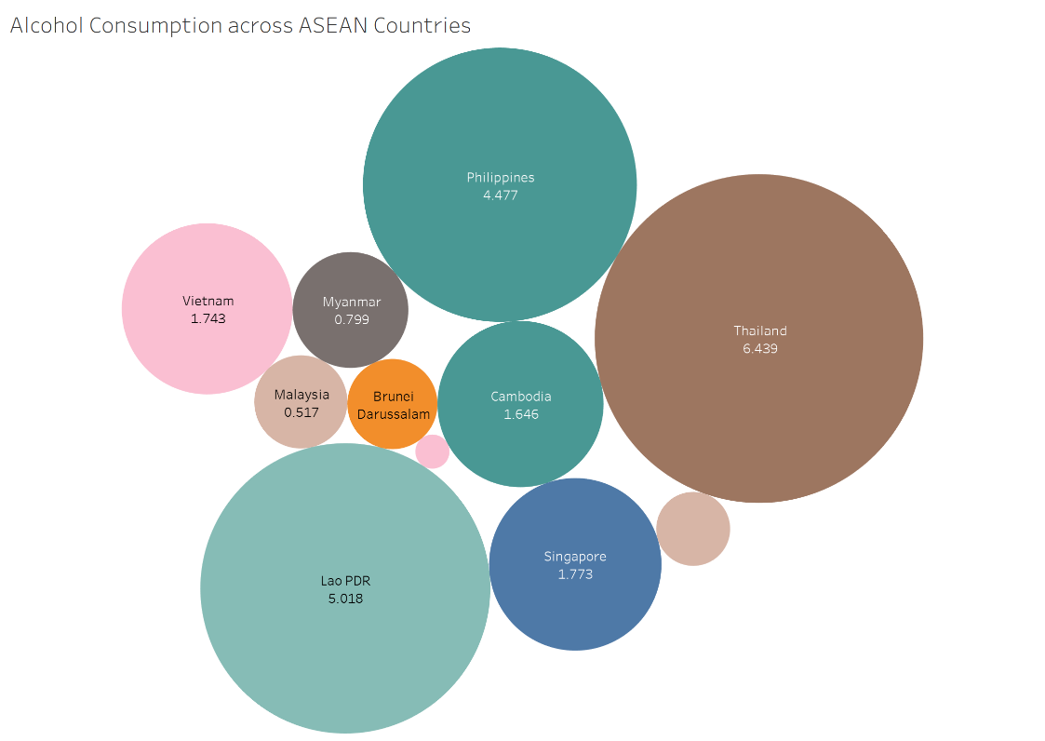

**Table 3.6**

**Interpretation**

Based on the above visuals, it answers two parts of the questions about the trend of alcohol consumption per year in Thailand and how they compare to other ASEAN countries by the size of the circle.

**Purpose**

We can see that Thailand have the largest circle, meaning having the biggest alcohol consumption which can impact life expectancy. Drinking too much alcohol can result in shorter life expectancy. Based on a source, it says:

“Excessive alcohol consumption can lead to several health complications. Arguably most serious are the possible adverse effects on the heart, including high blood pressure, stroke, arrhythmias, and cardiomyopathy. Alcohol can also cause or contribute to liver steatosis (fatty liver), alcoholic hepatitis, fibrosis, and cirrhosis. Additionally, alcohol consumption has been linked to head and neck cancer, oesophageal cancer, liver cancer, breast cancer, and colorectal cancer.”

Therefore, this would show that the consumption of alcohol is one of the many factors contributing to a lower life expectancy.

## 3.4 BMI

### 3.4.1 What is the trend of BMI per year in Thailand, and how does the BMI compare with other ASEAN countries?

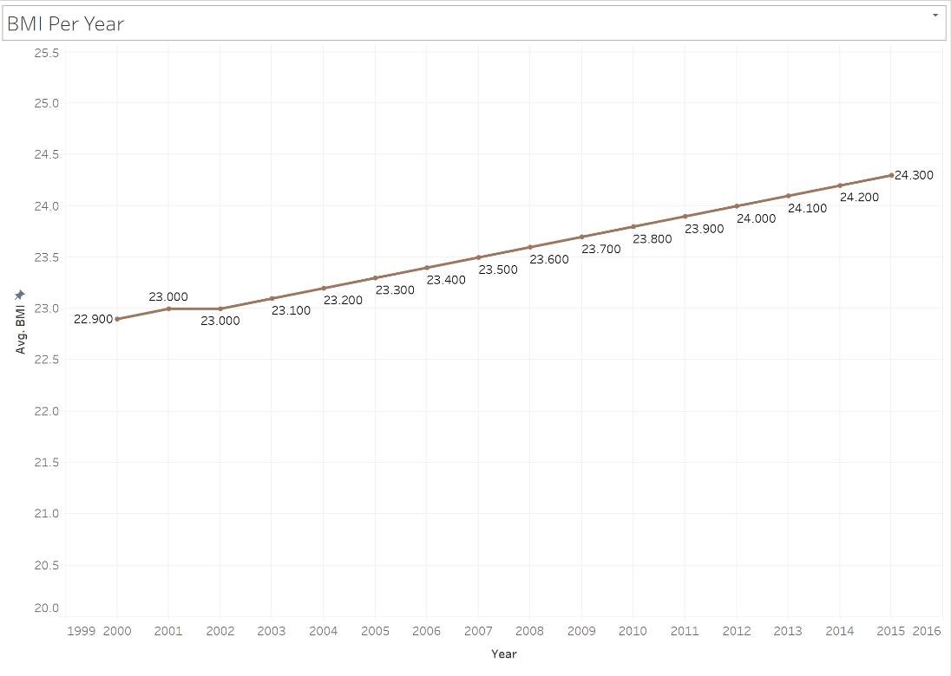

**Table 3.7**

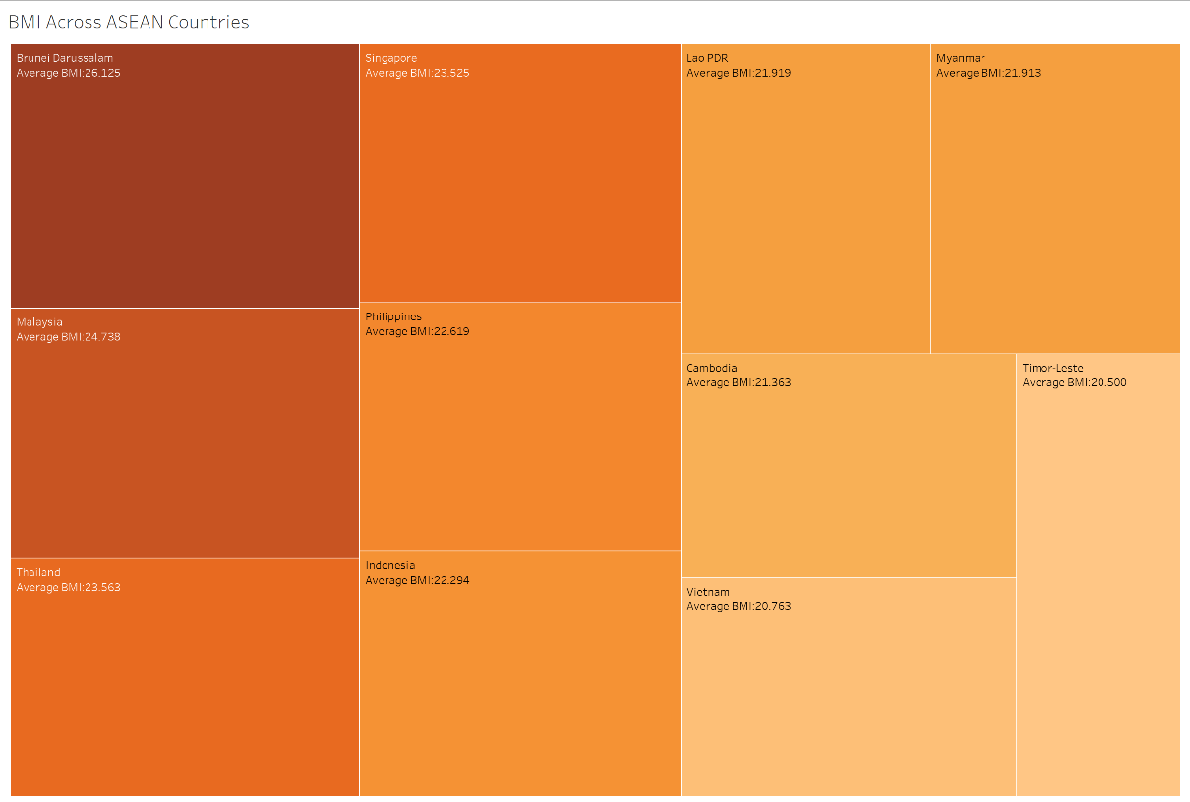

**Table 3.8**

**Interpretation**

From the above visuals, it answers two part to the question. It shows the trend of BMI per year in Thailand and compares it with the prevalence of HIV in other ASEAN countries.

**Purpose**

Body mass index (BMI) is a person’s weight in kilograms divided by the square of height in meters, which is a method used for weight measurement. Based on this table on how to measure BMI:

|  |  |
| --- | --- |
| BMI | Weight Status |
| Below 18.5 | Underweight |
| 18.5 – 24.9 | Healthy Weight |
| 25.0 -29.9 | Overweight |
| 30.0 and above | Obesity |

Based on the visuals, we can see that Brunei which has the largest box among the other countries at 26.125 which falls under the overweight status. While Timor-Leste have an average BMI of 20.5 which is a healthy weight. Therefore, this shows how Thailand stands after comparing with Brunei and should remain in the healthy zone as BMI is one of the many factors contributing to either a higher or lower life expectancy.

## 3.5 Incidence of HIV

### 3.5.1 What is the incidence of HIV in Thailand, and how does it compare with the prevalence of HIV in other ASEAN countries?

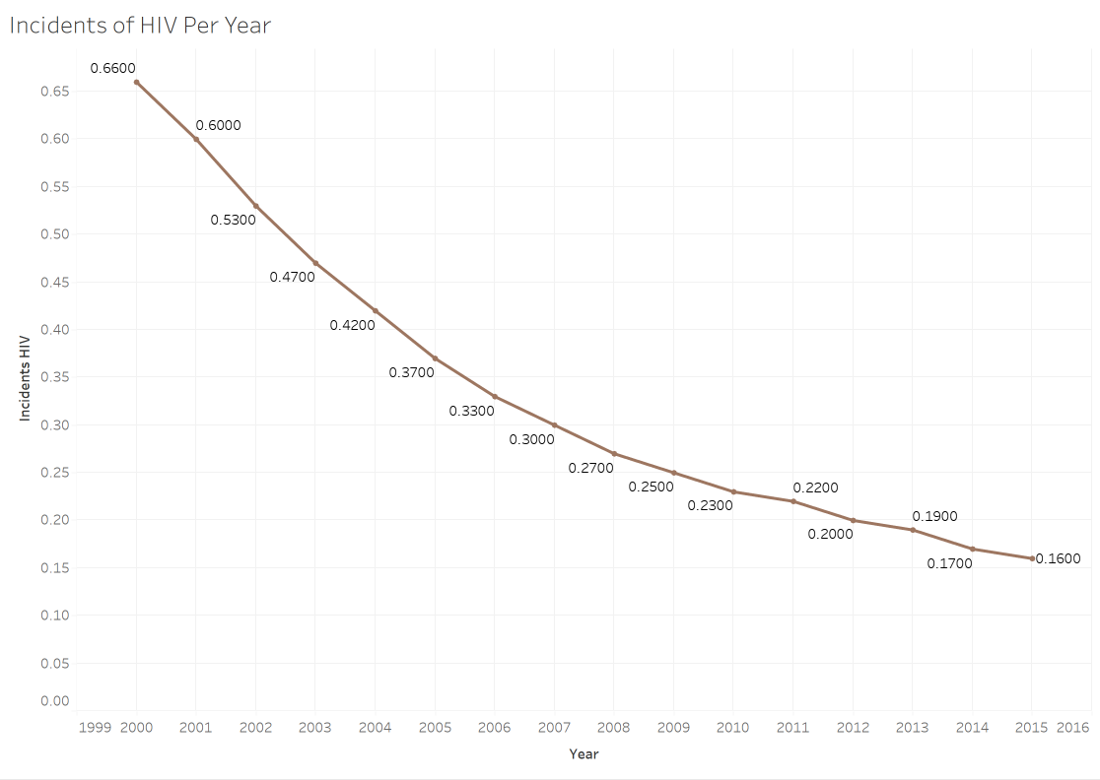

**Table 3.9**

**Table 3.10**

**Interpretation**

Based on the visuals, it answers two parts to the question. Firstly, it shows the trend of incidence of HIV in Thailand and compares it with other ASEAN countries.

**Purpose**

From the visuals, we can tell that for Thailand there have been a downward trend from 2000 – 2015. However, as it compares itself to other countries, it ranked second highest in HIV which is not relatively a good sign. HIV are dangerous as they are viruses that attacks the body’s immune system, if not treated, it could lead to AIDS and once they get HIV, they live with it forever even being able to control it. If not taken serious, it could significantly reduce their life expectancy. Therefore, healthcare sector should try to raise awareness of the risk of HIV in order to reduce and bring the numbers down.

## 3.6 GDP per capita

### 3.6.1 What are the trends in GDP per Capita?

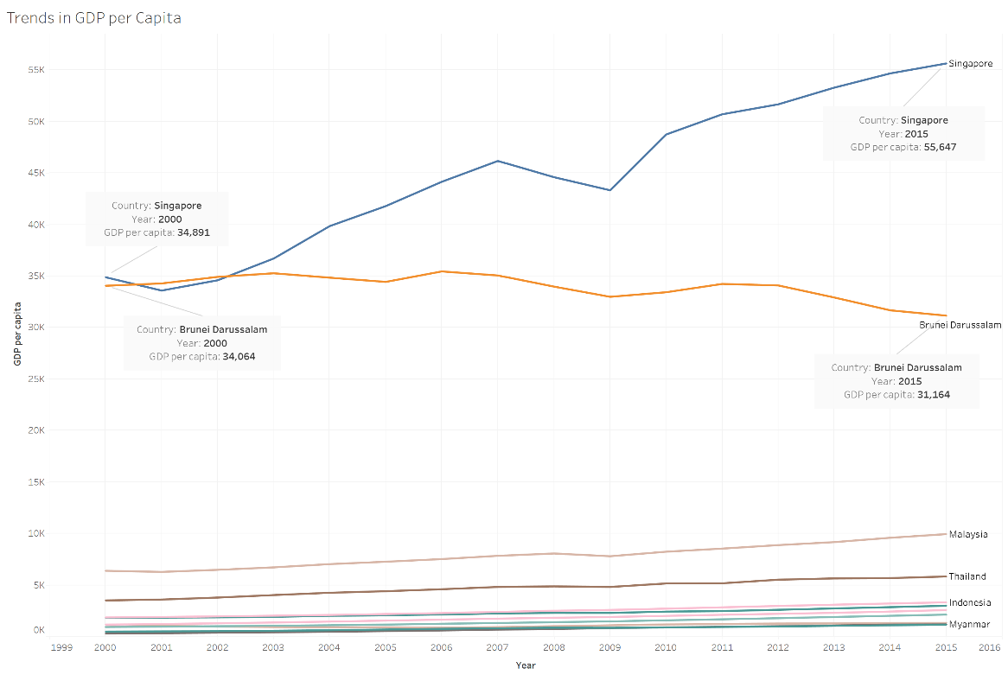

**Table 3.11**

**Interpretation**

From the line chart. We can see the different lines for each ASEAN countries. But I would like to shift the focus to Singapore (Blue Line) and Brunei (Orange Line) on why it is doing better than the other countries.

**Purpose**

GDP per capita is a measurement of the GDP per person in a country’s population. Indicating the amount of output or income per person in an economy. In the year 2000, Singapore and Brunei were very close to each other with Singapore at 34,891 and Brunei at 34,064. But as times passes, Singapore was on a upward trend while Brunei was on a downward trend. By 2015, Singapore GDP was at 55,647, which is a 59.4% increase in 15 years. While Brunei was at 31,164, which is an 8.51% decrease in 15 years. Even with the Global Economic Crisis that happened from 2008 – 2009, Singapore was still able to recover afterwards. Overall, countries with higher GDP can invest more money into the healthcare sector, such as improving the quality of healthcare services which allows the public to be treated or do regular medical screening. Therefore, GDP per capita is one of the many factors to contribute to either a higher life expectancy or lower life expectancy.

### 3.6.2 How does GDP per capita compare with the average Life Expectancy?

Year:2000

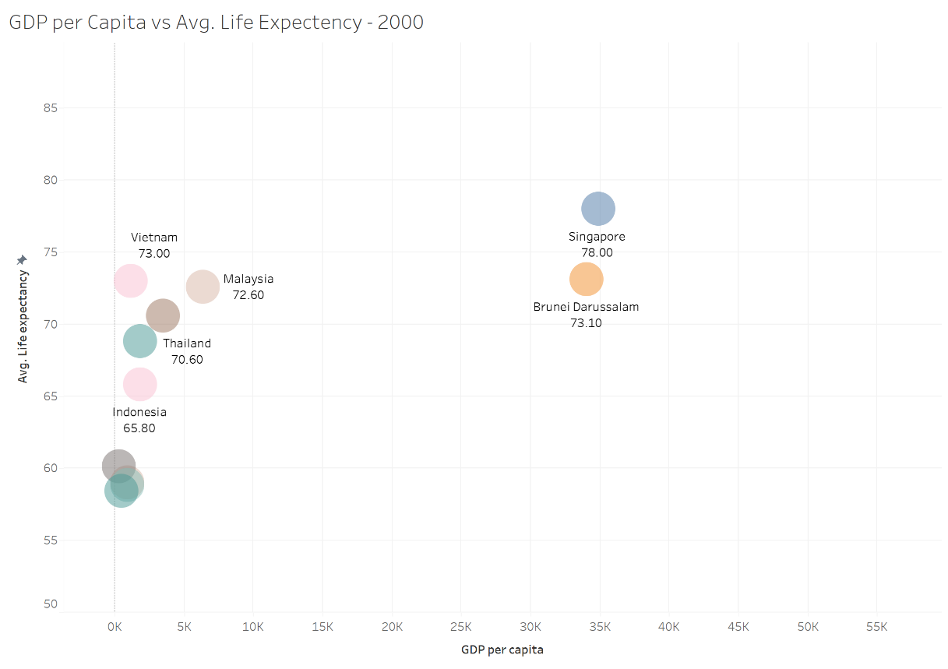

Year:2015

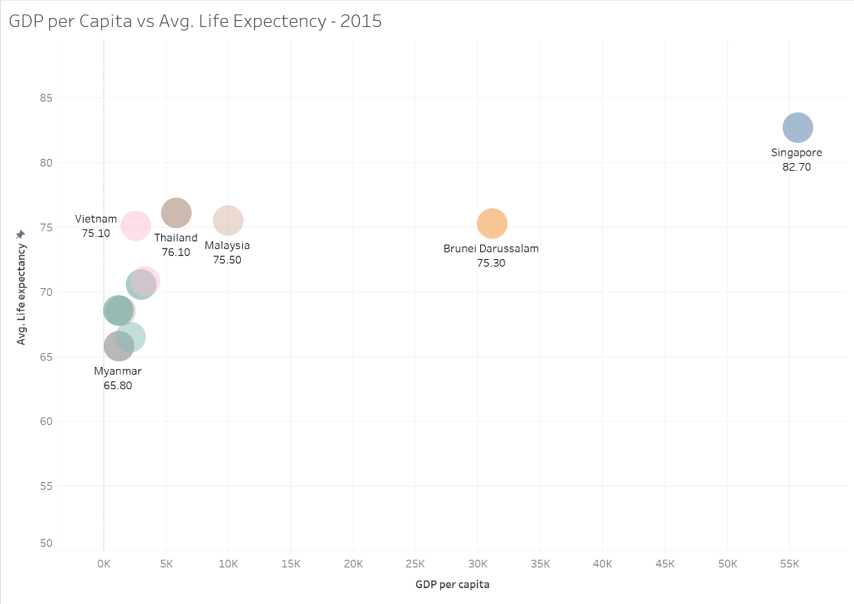

**Table 3.12**

**Interpretation**

In relation to the previous line chart, here we can see the bubble chart that shows the average life expectancy as the years increases. With this bubble chart, we can see how each individual ASEAN country have fared across the 15 years.

**Purpose**

Based on the bubble chart, we now have a clearly understanding that why GDP is one of the many factors that contribute to having a higher or lower life expectancy. As you can see from the table above. In 2000, Singapore and Brunei were relatively close in GDP, Singapore life expectancy at 78 years old and Brunei at 73 years old on average. As the years goes by, mostly for every country, as the GDP increased, life expectancy also steadily increased. For example, fast forward to 2015 Singapore Life Expectancy was at 82 years old, Thailand Life expectancy was at 72.60, however Brunei ended up at 75.30 which is not a big increase considering it has a bigger GDP compared to Malaysia for instance. This could show that other factors might have occurred to result in this small increase, or the healthcare sector was not greatly improved. Therefore, the significance of a countries GDP translates to how well a country can afford to spend on developments especially the healthcare sector to provide quality healthcare services to the public.

## 3.7 Immunization Coverage

### 3.7.1 How does Immunization Coverage look like in Thailand and what is the trend in immunization coverage per year across ASEAN countries.

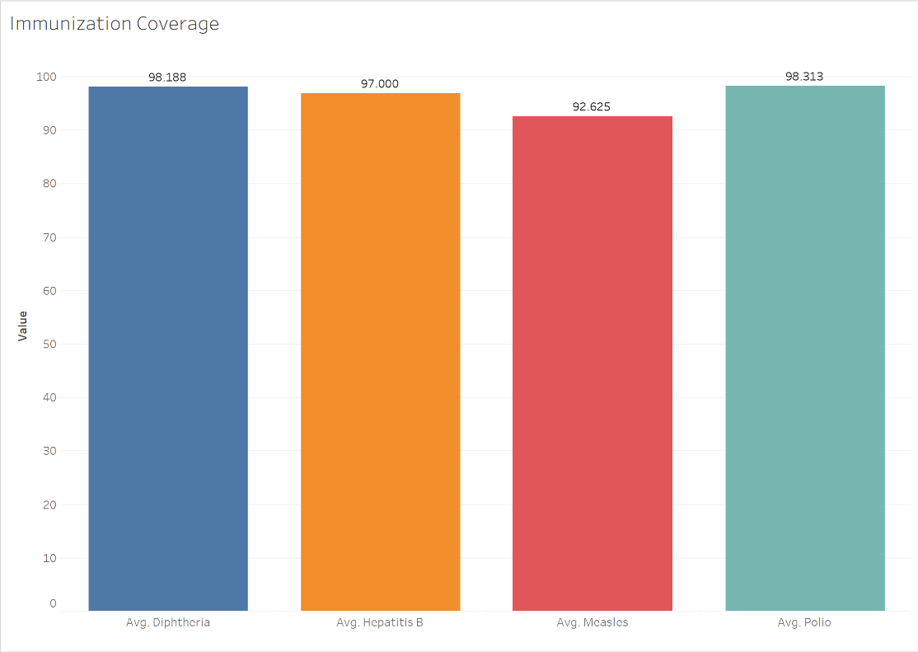

**Table 3.13**

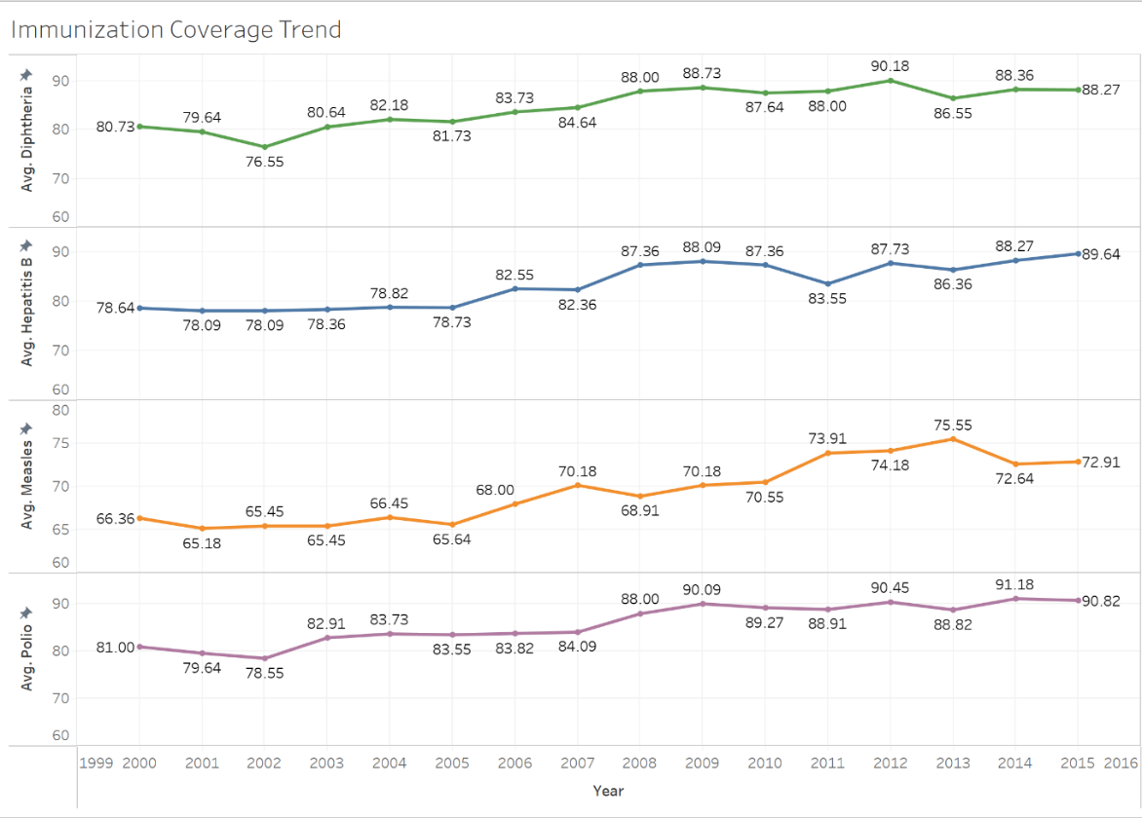

**Table 3.14**

**Table 3.15**

**Interpretation**

Based on the visuals, it answers two parts of the question where it shows the immunization coverage in Thailand and the trend in coverage per year across ASEAN countries, to help understand it better, a stacked bar chart which shows the respective countries is also being included.

**Purpose**

Based on the visuals, this shows how consistent these immunizations are being given to the people. These immunizations are important as they achieve widespread immunity, and it’s important as it protects people from these which could potentially reduce their life expectancy. Diphtheria Immunization protects against diphtheria, which is a bacterial infection that could lead to severe respiratory issues. Polio Immunization prevents polio, a viral infection that can lead to paralysis. Measles immunization protects against measles, which is a highly contagious viral infection that can lead to pneumonia and encephalitis. Lastly Hepatitis B prevents hepatitis B, which is a viral infection that affects the liver and can lead to risk of chronic liver disease, liver cancer, and transmission of the virus from mother to child. These viruses and diseases can be very serious and can potentially affect the entire population if not properly protected against these. Significantly affecting a person’s life expectancy if these vaccines are not taken from young, or it could expose them widely to these dangerous viruses and ultimately shorten their life expectancy. Therefore, taking these immunizations and consistently giving them to the young can lead to longer life expectancy as they are being protected.

## 3.8 Mortality Rate

### 3.8.1 What are the mortality rates in Thailand, and how they evolved over the years? Where does Thailand’s mortality rate stand in comparison to other ASEAN countries?

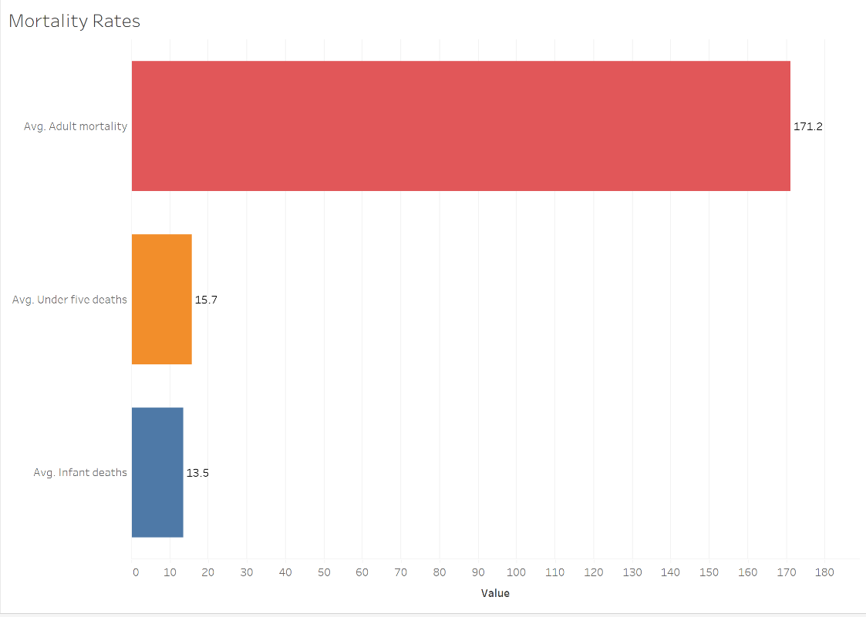

**Table 3.16**

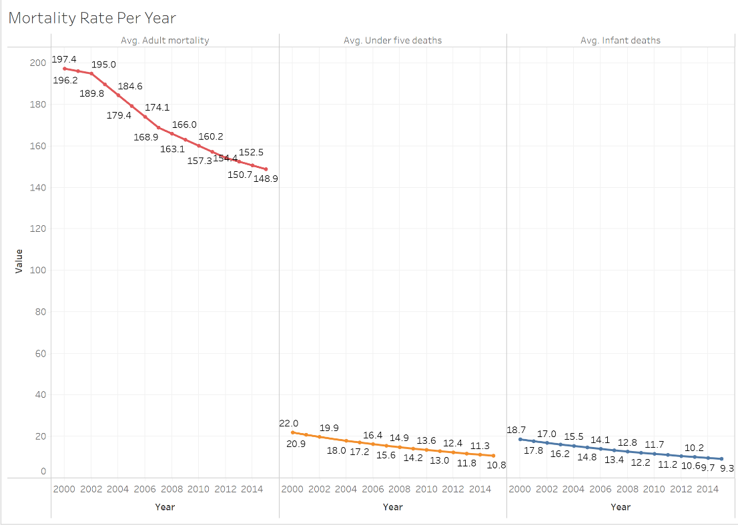

**Table 3.17**

**Table 3.18**

**Interpretation**

Based on the visuals, it answers three parts of the question. It shows the mortality rates in Thailand, afterwards showing the trend of how these mortality rates have decreased over the years and lastly how it stands among other ASEAN countries for each respective mortality type.

# 4) Dashboard

* From your library of visualisations created earlier, identify suitable ones to create a dashboard. Recall that dashboards should incorporate only visualisations related to one main topic.
* Depending on your exploratory questions, create multiple dashboards to aid you in performing your storytelling presentation subsequently.

Before coming up with the visualisations to create the dashboards, certain considerations were made to ensure the dashboards curated had a story to tell. So, the 4Ws were considered:

1. Who:
   * 1. The visualization is targeted towards MOPH as they might be interested to find how these health challenges affect the populations life expectancy and what they can do to improve life expectancy.
2. Where:
   * 1. This interface can be viewed on desktop, tablet, or phone. However, it will be best to view it on a desktop which my visuals are optimised to display the information clearly.
3. Why:
   * 1. As the dataset can be quite complex, I hope that through data visualization, the MOPH are able to understand and view the data with ease.
4. What:
   * 1. The visuals will address my explanatory questions and when coming onto the dashboard aims to compile the different visuals I have together for easy referencing and understanding.

### 4.1 Life Expectancy Dashboard

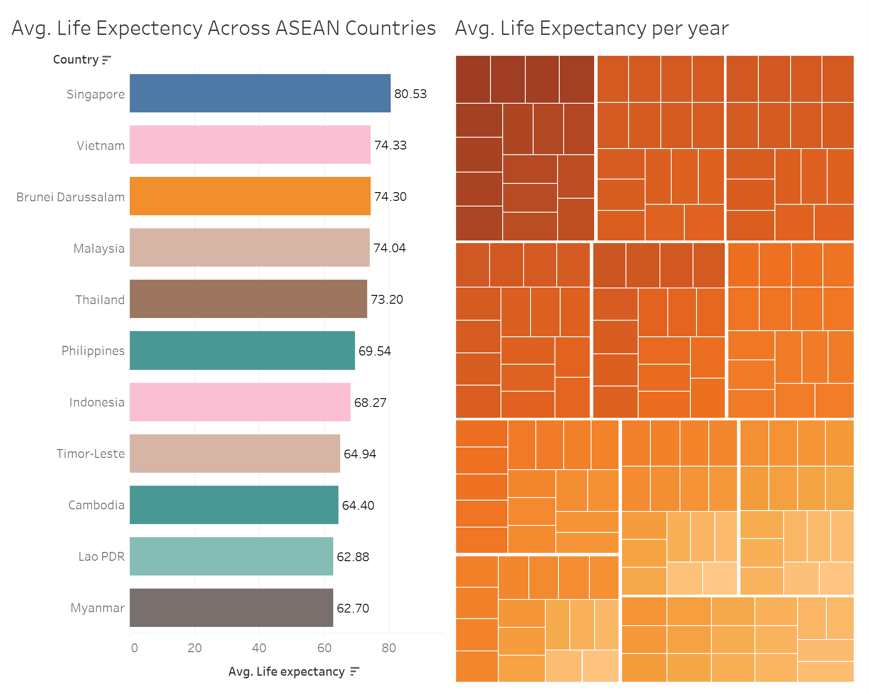

**Table 4.0**

### 4.2 Alcohol Consumption Dashboard

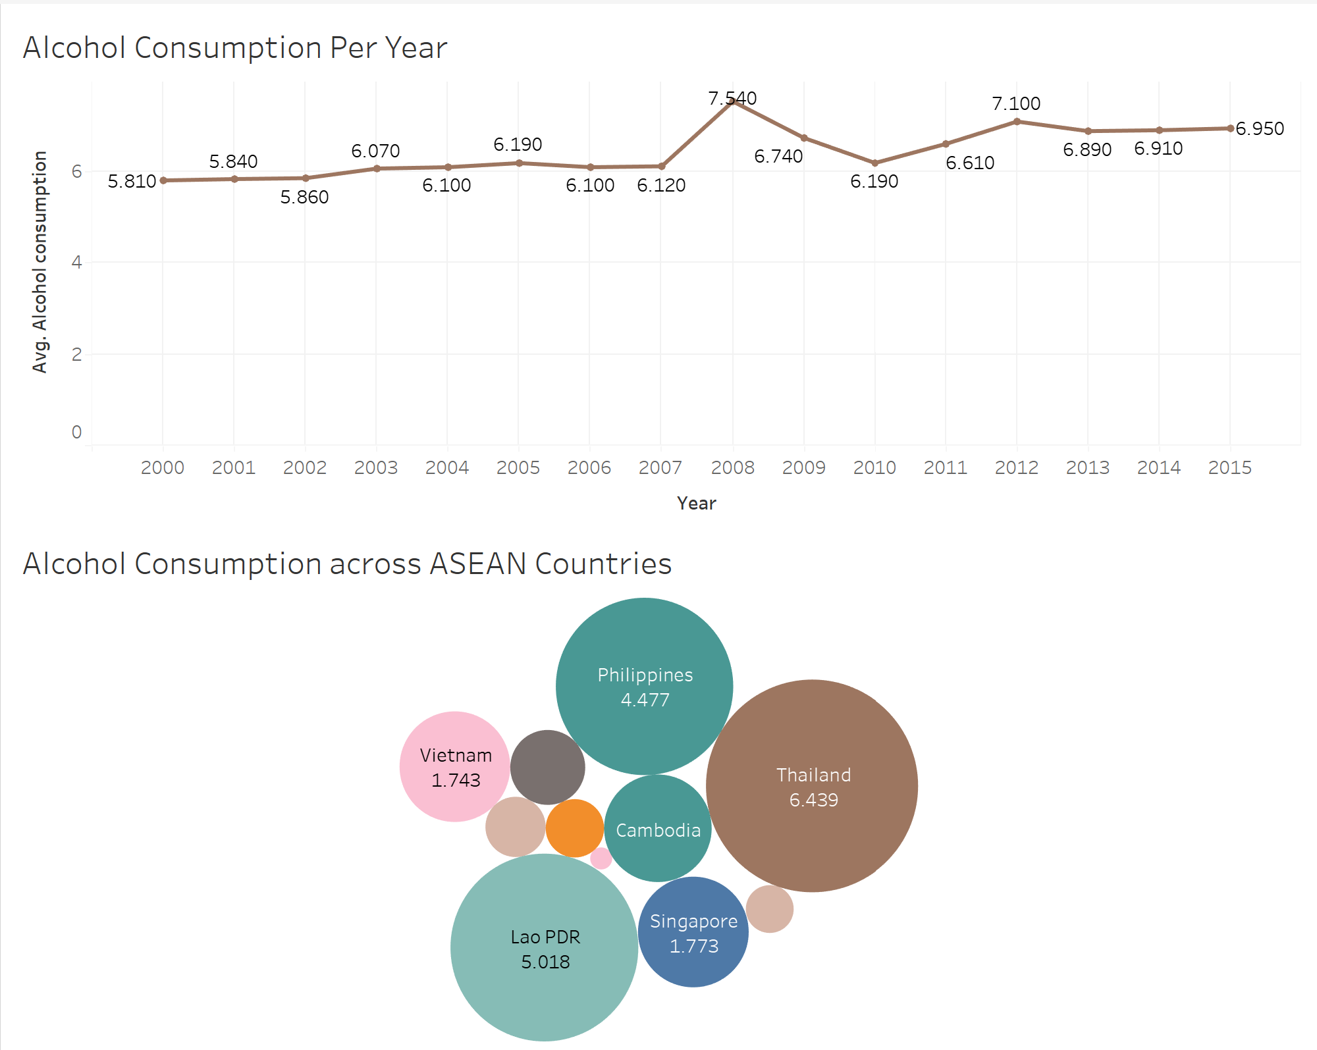

**Table 4.1**

### 4.3 BMI Dashboard

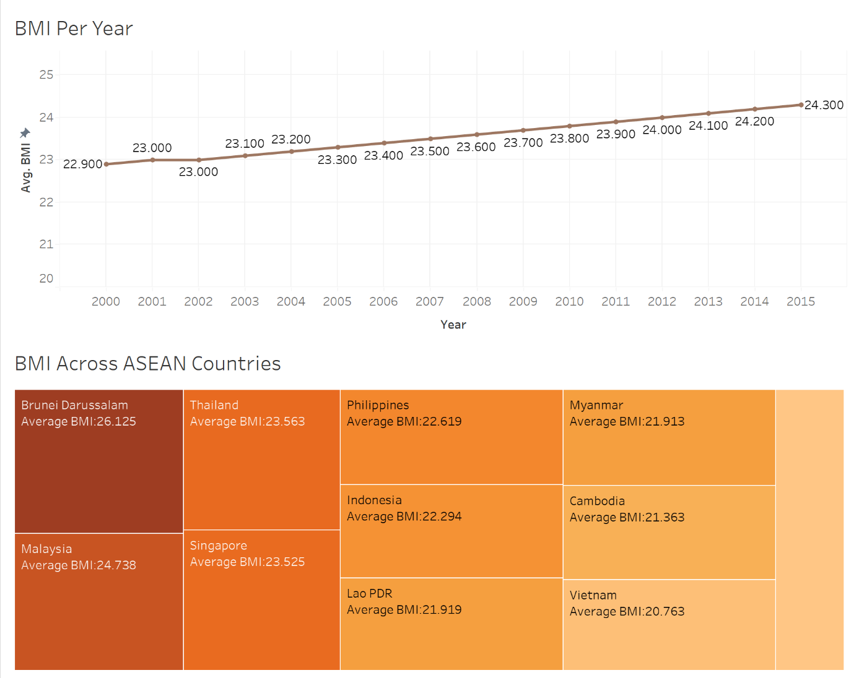

**Table 4.2**

### 4.4 HIV Dashboard

**Table 4.3**

### 4.5 Immunization Coverage Dashboard

**Table 4.4**

### 4.6 Mortality Dashboard

**Table 4.5**

# 5) Recommendation Summary

### 5.1 Raise more awareness by educating the public

By educating the public on the risk of high-level alcohol consumption and unsafe BMI level,

people will start to take notice of the risk and act against it by reducing their alcohol intake and always maintaining a healthy lifestyle to keep their BMI on the safe level. These initiatives will allow more people to stay healthy and reduce risk of disease. Therefore, allowing them to live a good and long quality life.

### 5.2 Advocate for better healthcare policies

Even with current healthcare policies, not everyone is able to afford healthcare services as they might not have the financial resources to do so especially in some ASEAN countries. Hence, advocating for healthcare policies that aid people who are in the low social status group receive quality medical screening even once per year, can significantly benefit them even if the services are limited to basic screening. This healthcare policies will play a huge role in ensuring everyone are healthy.

### 5.3 Ensure kids take mandatory immunization coverage

To prevent the risk of getting the disease, it is important kids to receive these immunizations shots. This significantly reduces the risk of as these disease/viruses as they might suffer from it such as death if not treated. Therefore, it is important for everyone especially kids to receive it.

# 6) Conclusion

## 6.1 Reflection

### 6.1.1 How have your findings on ASEAN countries challenged or broadened your understanding of regional diversity and interconnectivity?

Firstly, through my findings on ASEAN countries, it challenged my understanding of regional diversity by highlighting the wide range of socioeconomic development levels across these ASEAN countries. For example, Singapore and Brunei, have indeed achieved high levels of income and human development, however countries such as Laos and Myanmar, faces many challenges that resulted in them not doing as well as Singapore and Brunei. Therefore, different country requires different type of needs and approach in order to develop.

Secondly, it also broadened my understanding of regional interconnectivity like how countries in ASEAN are interconnected. Like how when 1 country suffered from the Global Economic Crisis, the rest also suffered one way or another. Hence, posing a challenge in maintaining regional stability.

### 6.1.2 What are some key challenges and opportunities you observed among the ASEAN countries in terms of their socio-economic development? How do these findings contribute to your understanding of the ASEAN community?

Some of the key challenges I observed among the ASEAN countries is firstly socio-economic disparities. Other than life expectancy itself, many factors affect life expectancy. These factors could be due to poverty, inequality, infrastructure development and environmental sustainability. Even with these challenges, many opportunities are seen within ASEAN countries such as strategic location planning in the global economy.

These findings contribute to my understanding of the ASEAN community by reinforcing the importance of regional cooperation in addressing shared interest and challenges, seizing opportunities that is ultimately for the greater good of the people.

### 6.1.3 In what ways do the findings on ASEAN countries inspire you to reflect on Singapore’s position within the region and its role in fostering regional collaboration and growth?

The findings on ASEAN countries allowed me to be grateful for the environment and status I am living in, even though Singapore is a tiny red dot, it has established it’s mark around the world. For example, Singapore have great relations with many countries such as the US with its free trade agreement. Not only that, but Singapore’s Changi Airport is also well known around the world, establishing itself as one of the best airports. Lastly , Singapore trading port is also very established with goods being traded freely without any heavy fees. Singapore relation with the other ASEAN countries remains strong especially with big countries such as China, USA, and India. Singapore have come a long way from where it started, from a 3rd world country to a 1st world metropolitan city with one of the highest GDP. Hence, it gives me a greater appreciation for the great quality of education, environment and opportunities I have yet to explore.

## 6.2 Conclusion

After doing this assignment, I have learned so many things that I previously did not know. Such as the UN Sustainable Development Goals and what they want to achieve. Not only that, I also learned more about the other ASEAN countries. By doing research on them, I learned new information on certain questions I ask myself or the things I am curious about. This assignment has been beneficial towards me in raising my awareness of the UN’s goal and how they are actively trying to reach their goals by the end of 2030 for some goals. Gaining a deeper understanding and appreciation for their effort in trying to resolve these challenges.

# 7) Reference

BMI Research - <https://www.cdc.gov/healthyweight/assessing/bmi/adult_bmi/index.html>

Alcohol Consumption Research -1 - <https://www.who.int/news-room/fact-sheets/detail/alcohol>

Alcohol Consumption Research-2 - [Alcohol Consumption by Country 2023 (worldpopulationreview.com)](https://worldpopulationreview.com/country-rankings/alcohol-consumption-by-country)

Immunization Coverage - <https://www.who.int/data/gho/data/themes/topics/immunization-coverage>

HIV Research - [About HIV/AIDS | HIV Basics | HIV/AIDS | CDC](https://www.cdc.gov/hiv/basics/whatishiv.html)

GDP per capita Research - <https://www.investopedia.com/terms/g/gdp.asp>

ChatGPT - [ChatGPT (openai.com)](https://chat.openai.com/)

Updated Dataset (Kaggle) - <https://www.kaggle.com/datasets/lashagoch/life-expectancy-who-updated>

Inspiration for visuals - <https://www.youtube.com/watch?v=Z1M4n52uLTo>

Originla Dataset (Dataset) - [Life Expectancy (WHO) (kaggle.com)](https://www.kaggle.com/datasets/kumarajarshi/life-expectancy-who/)